
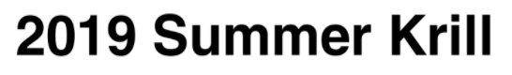

From | Kate’s understanding of the Meeting
To | Shallin Busch Paul McElhany, Mike Maher, Danielle Perez
Date | Wednesday 2021.03.09 (Last Draft)
SUBJ | Respirometry Narrative
Drive | https://drive.google.com/drive/folders/1sMiXNW6YCKHZoMop1wlQl-i1HPmBZEEW?usp=sharing
REPO
Study | 2019 Krill Exposure Cross Study

Table of Contents

- Respirometry Protocol Description & Refresher
- Respirometry Project “NWFSC.MUK_KRL2019respirometrySLOPES”
  - Overview of Dataframes
  - Overview of Units
- Trial Plots
- Outlier Removal
- Correcting Slopes (blanks and animal wet weight)
- Summary Statistics
- Mixed Effects Model

1.0 Respirometry Protocol Description & Refresher
1.1.a Respirometry and Project End Goals. Four lipid samples from each MOAT at the end of the study. Whole body “MORTs” were measured to get a sense of the size for the animals as the study progressed. The termination of the study was biomass dependent.
Other Samples Collected for Lipids Analysis.
A wild cohort was measured for both their size and wet weight.
72 animals were selected for respirometry
112 other animals were prepared for lipids analysis (including wild cohort)
184 total number of animals were sent for lipids analysis

Google Drive | Lipids Documents (Louise Copeland Lab)
https://drive.google.com/drive/folders/1ViSaymvzDdrf1Xu2ZRz79vqYLQRvC6lp?usp=sharing
Google Drive | Lipids Documents (NWFSC prepared documents)
https://drive.google.com/drive/folders/1yDILSlUahFfrmPkOjkfjW2OcTXI-o0p1?usp=sharing
GitHUB | (McElhany Repository)
https://github.com/pmcelhany/krill_lipids.git

1.1.b Project’s End Respirometry Trials Determination
19 vials (volume 28.06mL) were available
Four trials were conducted over two day
Two blank vials were included per trial
“Krill Doctrine” was employed to determine how best to distribute krill across trials
Krill Doctrine
Fast krill for 24hours prior to respirometry and lipids analysis preparation
Choose MOATs with the lowest number of animals remaining for the first round(s) of respirometry and follow on preparation for lipids analysis
Balance between MOATs across days of respirometry
Balance between Treatments when choosing which respirometry round
Must achieve 4 vials per MOATs
Achieve 15-20 animals across treatments for respirometry
Wait until Night Time Conditions begin for the Krill to start Respirometry Trials. The night period for krill began at 1230pm.

1.1.c Project’s End Respirometry Trials Description
16 Animals per “Ambient Treatment”
16 Animals per “All Change Treatment”
16 Animals per “High Temperature Treatment”
- nimals per “Current Treatment”

2.0 Respirometry Project ““NWFSC.MUK_KRL2019respirometrySLOPES”
R scripts and documents inside the project listed above was generated to create slopes, intercepts, and apply linear/mixed effects models to the slopes.

2.1 Merging. The database is created by merging two datafiles that brought together observer data collected data about individual krill (NIKON SMZ715T with Sony Camera manufactured by Imaging Source (DFK 33UX226c) and IC capture and measure software packages) and the PRESENS (PreSens optical oxygen Fitbox4 sensor). The merged dataframe was referred to as “DRESPmsr”.

2.1a Creating the database
Google Drive | dRESP <- read.csv(file = "KRILL_Resp_alltrials.csv", stringsAsFactors = FALSE)  dim(dRESP) | dRESP
https://drive.google.com/file/d/19veU1VIWJSrzlMEoVsmDicNNEKG-kWpW/view?usp=sharing
Google Drive | dRESPanimal <- read.csv(file = "RespirometryTrials_all.Animal.Info.csv")  dim(dRESPanimal) | dRESPanimal
https://drive.google.com/file/d/1vdumqXO0O-3-htxKjtagctW3YLOZoGj3/view?usp=sharing
Google Drive | dRESPmsr <- merge(dRESP, dRESPanimal, by="SensorName") | dRESPmsr
https://drive.google.com/file/d/1pWiqUsxNBWs5nYindWgORBDG9eMeg4sB/view?usp=sharing

2.1b Merged database dRESPmsr
Contains all Animal Specific Information and Probe Measurements
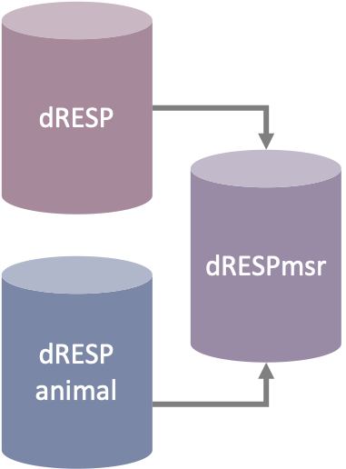
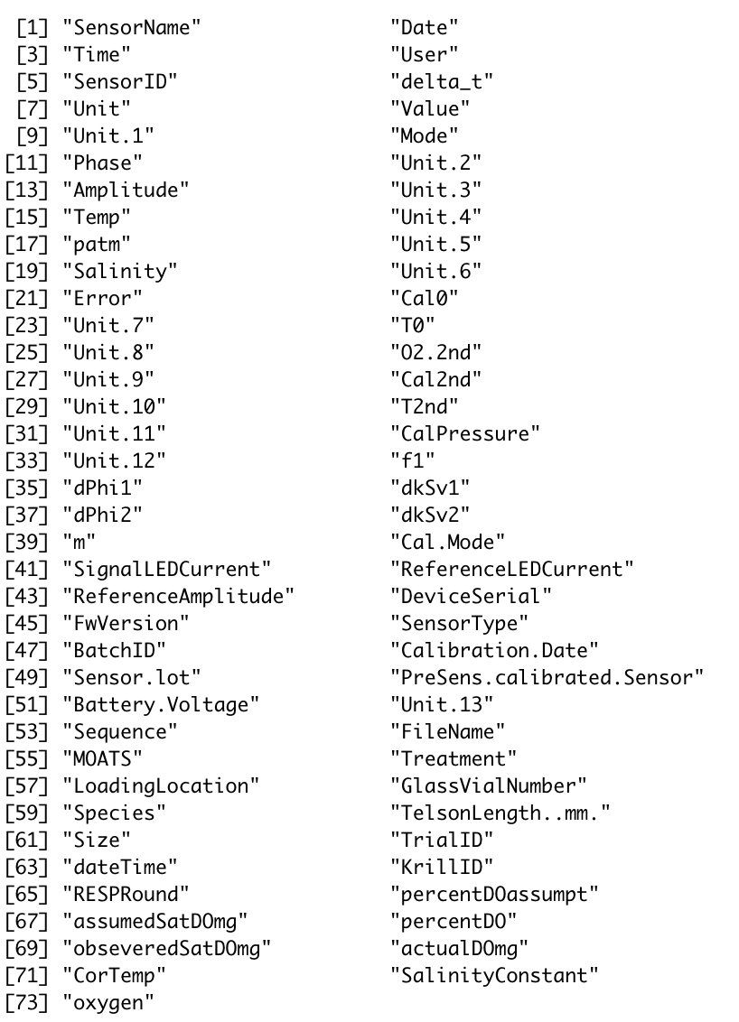
SHAPE \* MERGEFORMAT

2.2 DO Correction. On Trail 03 of Respirometry Day 02 the PRESENS default temperature of 14°C was entered. All krill under respirometry trials were kept in a water bath between 11.4-12℃. To correct for this temperature correction, Salinity constant was taken from the water supply MOATs 12 (30.3PSU) and modified with the package “wql”. Table below details the units of dissolved of oxygen, including volume inside the incubation vial.

2.2a DO Corrections and Oxygen Units
Following DO correction “oxygen” units is mg
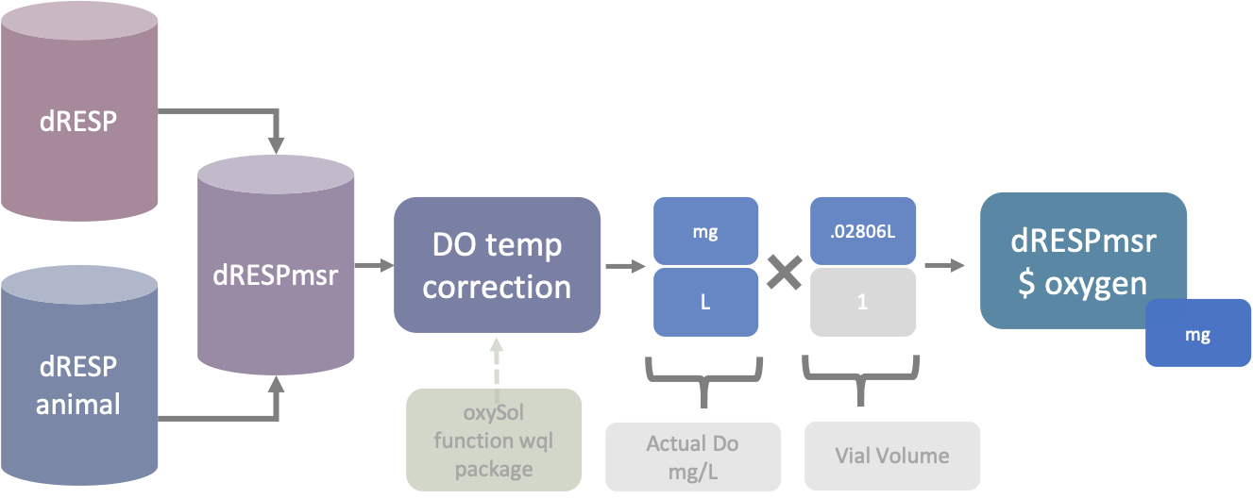
SHAPE \* MERGEFORMAT

Vial volumne was .02806. PRESENS probe measured Dissolved Oxygen as mg/L.

2.3 Units of Time. The PRESENS probe initially recording in minutes with decimal time.

2.3a Units of Time “delta_t”
Cumulative Amount of Time (.00hr)
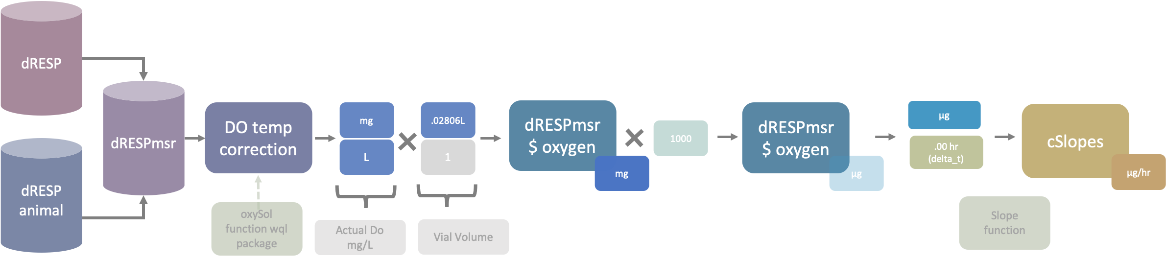
Observations were collected from start (T00) to 90minute completion (T90).
The “delta_t” value will increase until an approximate value of ~1.5hrs.

Simple slopes of krill respiration are recorded as μg / hr.
Slopes will later be corrected for background noise (blank slopes) and krill wet weight.

2.4 Animals Per Trial, Per Treatment Tables. The tables below detail how many animals have been included in each trial 01-04. The tables break down between treatments. The Ambient Treatment was initially included. The Respirometry 90 minute dataframe excludes the Ambient Treatment due a lack of consistent monitoring and equipment logs from both MOATs 04 and MOATs 05. 60 vials in all are included in analysis. With two blanks per trial, 52 animals are comprised those observed across three treatments.

Trial 1 of 4
Trial1Animals | Trial1_CHG | Trial1_CUR | Trial1_TMP | Trial1_Blanks
19 | 5 | 4 | 8 | 2
All Change  Conditions | Current  Conditions |  | High Temperature  Conditions
- "Trial01_KrilLR16"  - "Trial01_KrilLR17"  - "Trial01_KrILR110"  - "Trial01_KriLR116"  - "Trial01_KriLR117" | - "Trial01_KrilLR11"  - "Trial01_KrilLR13"  - "Trial01_KrilLR18"  - "Trial01_KriLR114" |  | - "Trial01_KrilLR14"  - "Trial01_KrilLR15"  - "Trial01_KriLR111"  - "Trial01_KriLR112"  - "Trial01_KriLR113"  - "Trial01_KriLR115"  - "Trial01_KriLR118"  - "Trial01_KriLR119"
Two blank vials included to complete a 19 vial respirometry test.

# [1] "Trial01_KrilLR12"
# [2] "Trial01_KrilLR19"

Trial 2 of 4
Trial2Animals | Trial2_CHG | Trial2_CUR | Trial2_TMP | Trial2_Blanks
11 | 5 | 4 | 0 | 2
All Change  Conditions | Current  Conditions |  | High Temperature  Conditions
- "Trial02_KriLR223"  - "Trial02_KriLR227"  - "Trial02_KriLR229"  - "Trial02_KriLR233"  - "Trial02_KriLR235" | - "Trial02_KriLR220"  - "Trial02_KriLR226"  - "Trial02_KriLR232"  - "Trial02_KriLR234" |  | character(0)
Two blank vials included to complete a 11 vial respirometry test.
Eight vials were originally collected from the “Ambient Treatment”,
all from MOATs 04 for the second round of respirometry

# [1] "Trial02_KriLR224"
# [2] "Trial02_KriLR230"

Trail 3 of 4
Trial3Animals | Trial3_CHG | Trial3_CUR | Trial3_TMP | Trial3_Blanks
19 | 5 | 4 | 8 | 2
All Change  Conditions | Current  Conditions |  | High Temperature  Conditions
- "Trial03_KRLr3_42"  - "Trial03_KRLr3_46"  - "Trial03_KRLr3_48"  - "Trial03_KRLr3_53"  - "Trial03_KRLr3_56" | - "Trial03_KRLr3_41"  - "Trial03_KRLr3_47"  - "Trial03_KRLr3_51"  - "Trial03_KRLr3_57" |  | - "Trial03_KRLr3_39"  - "Trial03_KRLr3_40"  - "Trial03_KRLr3_44"  - "Trial03_KRLr3_45"  - "Trial03_KRLr3_49"  - "Trial03_KRLr3_50"  - "Trial03_KRLr3_54"  - "Trial03_KRLr3_55"
Two blank vials included to complete a 19 vial respirometry test.
# [1] "Trial03_KRLr3_43"
# [2] "Trial03_KRLr3_52"

Trail 4 of 4
Trial4Animals | Trial4_CHG | Trial4_CUR | Trial4_TMP | Trial4_Blanks
10 | 1 | 7 | 0 | 2
All Change  Conditions | Current  Conditions |  | High Temperature  Conditions
- "Trial04_KRLr4_70" | - "Trial04_KRLr4_58"  - "Trial04_KRLr4_62"  - "Trial04_KRLr4_65"  - "Trial04_KRLr4_67"  - "Trial04_KRLr4_71"  - "Trial04_KRLr4_75"  - "Trial04_KRLr4_76" |  | character(0)
Two blank vials included to complete a 11 vial respirometry test.
Eight vials were originally collected from the “Ambient Treatment”,
all from MOATs 05 for the second round of respirometry

# [1] "Trial04_KRLr4_59"
# [2] "Trial04_KRLr4_68"

3.0 Timeseries Plots (prior to slope function). The figures below detail the decrease in oxygen per vial over time in each trial. The figures are broken apart by treatment. The “n/a” treatment refers to blank vials, filled only with filtered seawater from MOATs 12.

3.1a Trial 01 Percent Dissolved Oxygen Reduction Timeseries
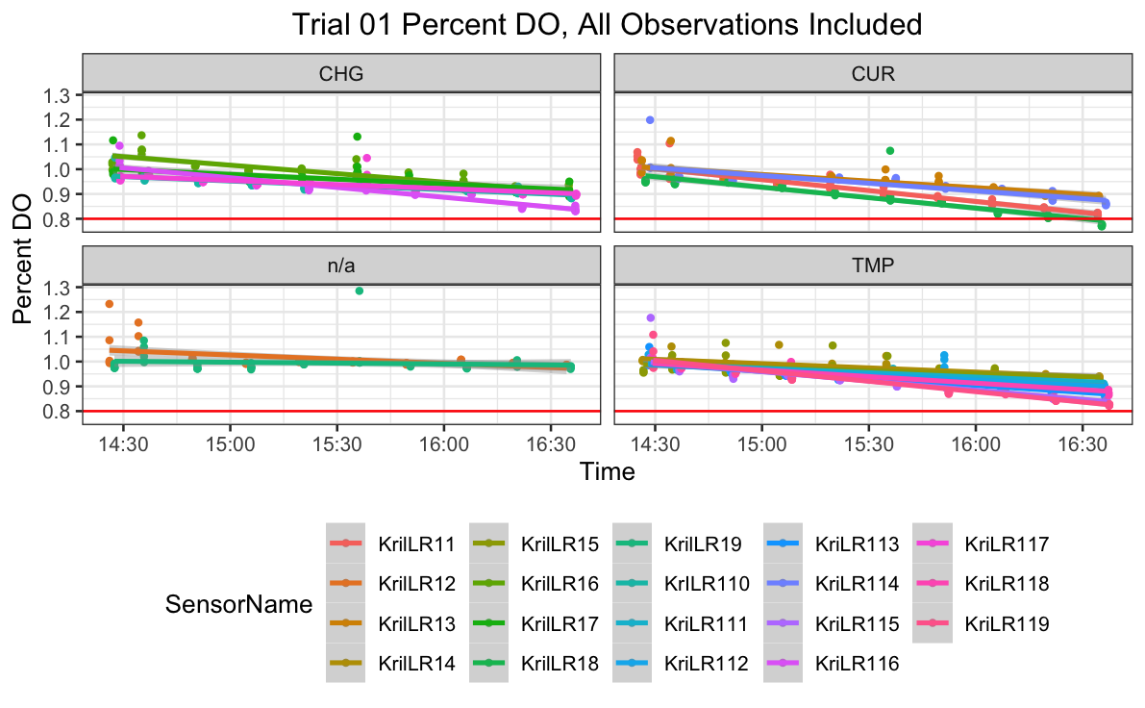
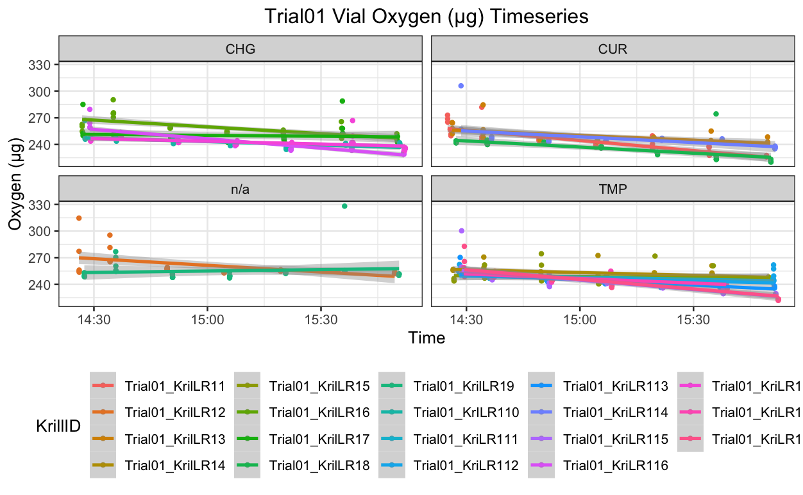

3.2 Trial 02 Percent Dissolved Oxygen Reduction Timeseries

3.3 Trial 03 Oxygen (μg) Reduction Timeseries
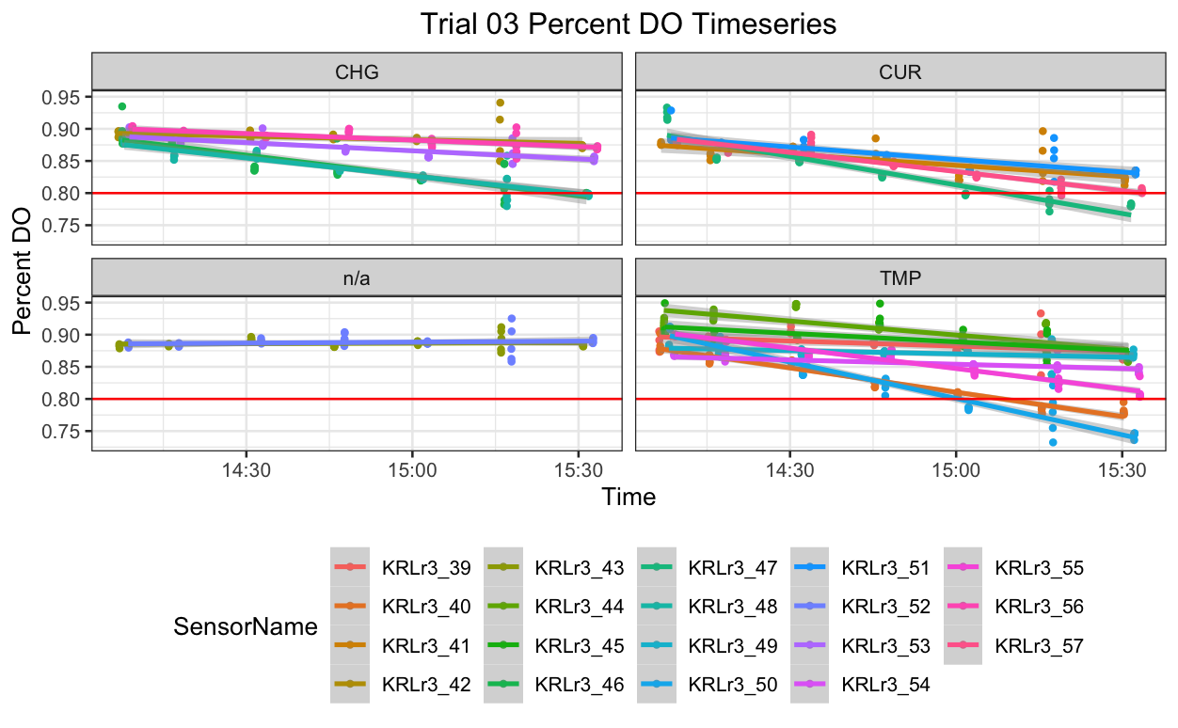
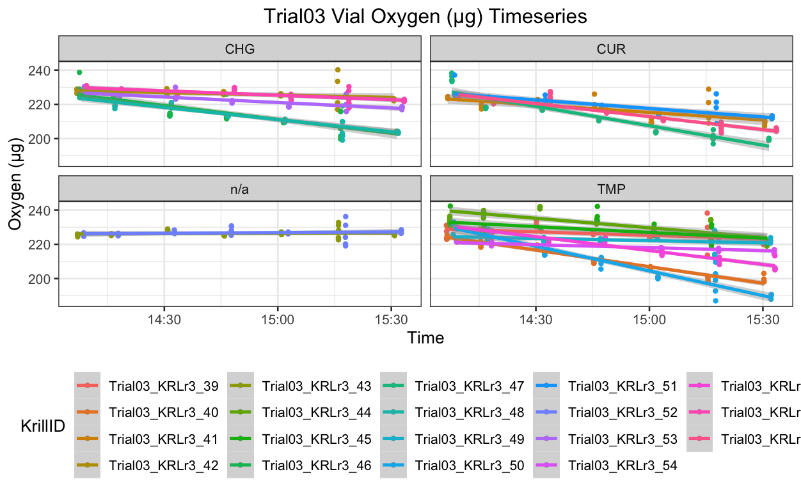

3.4 Trial 04 Oxygen (μg) Reduction Timeseries
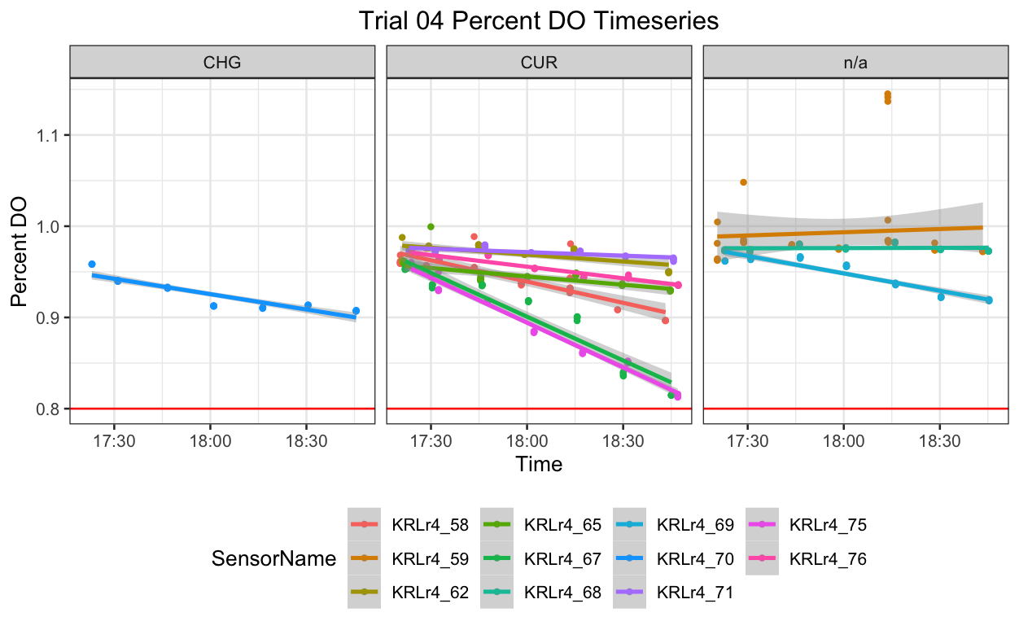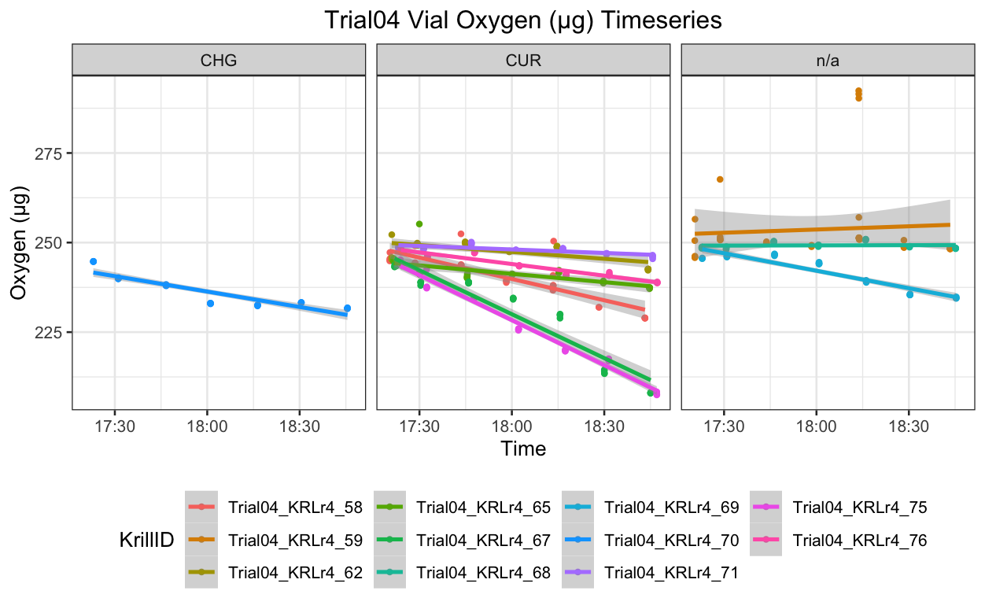

3.5 All Trials, Across Treatments Oxygen (μg) Reduction Timeseries
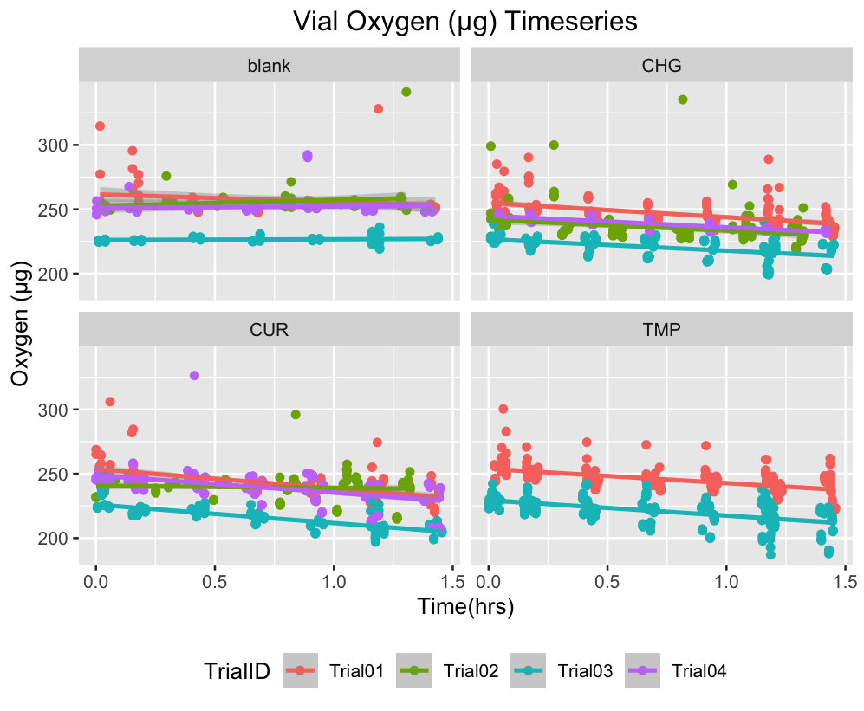

All trails are included. 52 animals and 8 blank vials are included in the figures above.

3.6 All Trials, Across Treatments Actual Dissolved Oxygen (mg) Reduction Timeseries
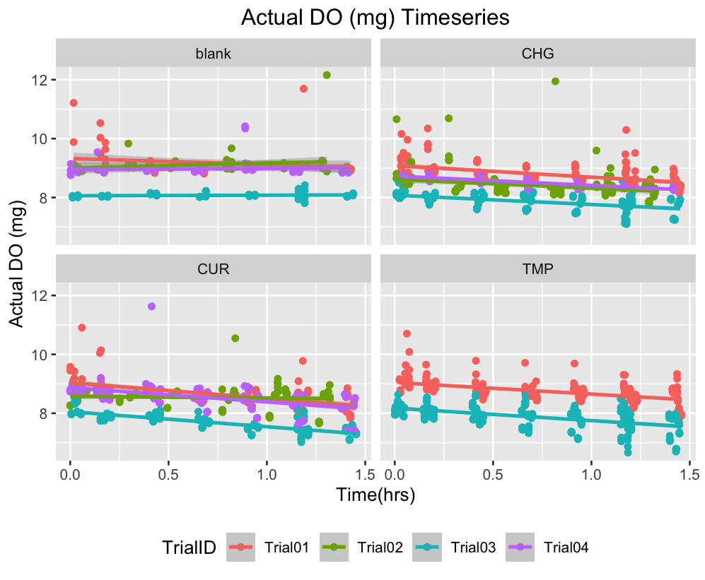

All trails are included. 52 animals and 8 blank vials are included in the figures above.

4.0 Outlier Removal. Removing outliers was a six step process to remove observations that had a Cook’s Distance above 4/n. The following table details those steps below:

Step | Line Command | Example of the Line Command
1 | Use the unique tool to get names for each krill | 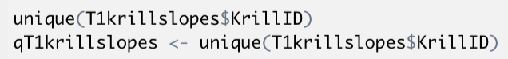
2 | Create a linear model object for all observations of one krill
3 | Using the fortify function, search residuals for cook.sd score for each observation
4 | Identify observations with cook.sd score above 4/n
5 | Use one dataframe to sort another  (removing the outliers)
6 | Rbind back the filtered dataframes | 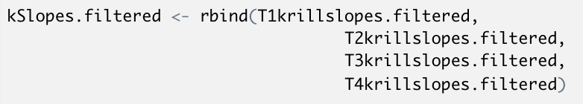

5.0 Blank Slope Averages & Correcting Slopes based on blank vials and animal wet weight

1 | Sub setting only the blank vials | 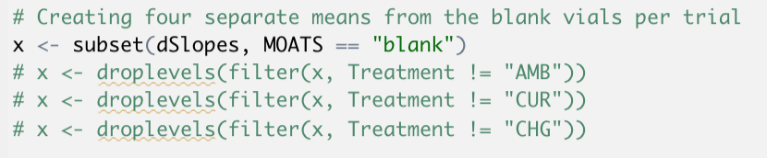
2 | Creating four different averages based on Trial No. | 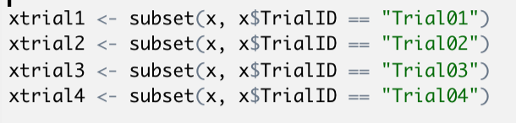
3 | Setting mean values to new variable names | 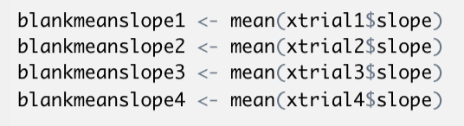
Blank Mean  Slope Trial 01 |  | -4.7994
Blank Mean  Slope Trial 02 |  | 0.4331
Blank Mean  Slope Trial 03 |  | 0.4478
Blank Mean  Slope Trial 04 |  | -.6710
4 | CorrSlope  Creating  (only subtracting the blank mean values) | 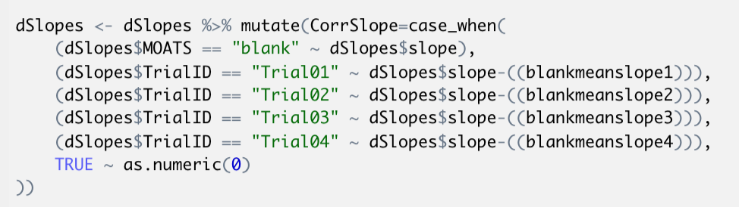
5 | Correcting for wet animal weight | 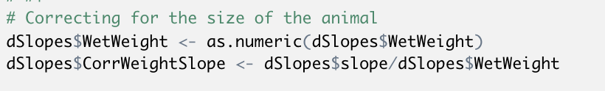
“CorrWeightSlope” value factors in both the blank mean (specific to Trial) and the animal wet weight

6.0 Slopes Plots

6.1 Slopes Prior to Blank Correction by Treatment (Vial Oxygen (μg)/hr)
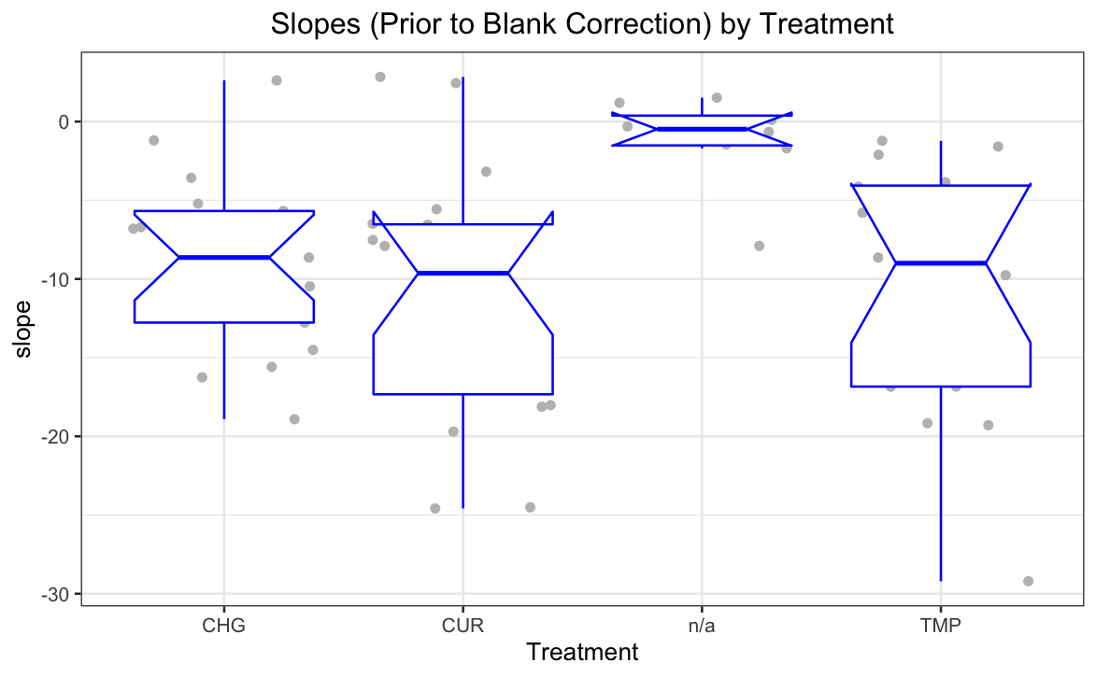

Notice that the negative slopes range from a slight positive to dramatically negative (almost negative 30). These numbers (-1, -4, -18 etc.) will go further negative as the blank slopes are subtracted . Then the weight in grams of the animal will divide that new corrected slope.

6.2 Slopes with Blank Correction by Treatment (Vial Oxygen (μg)/hr per gram of Krill)
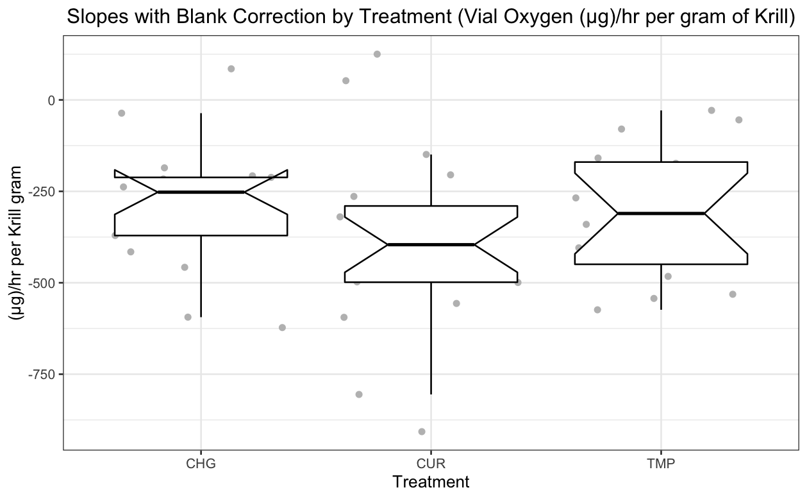
Inventing Units of Measurement (Ideas):

GillKicks
Chubles <- “Chubby Exhales”
Scrupulum
Krilpulumns

